**PID Regler**

Video English: [**https://www.youtube.com/watch?v=JEpWlTl95Tw**](https://www.youtube.com/watch?v=JEpWlTl95Tw)

Gain Gewinn

Slope Steigung

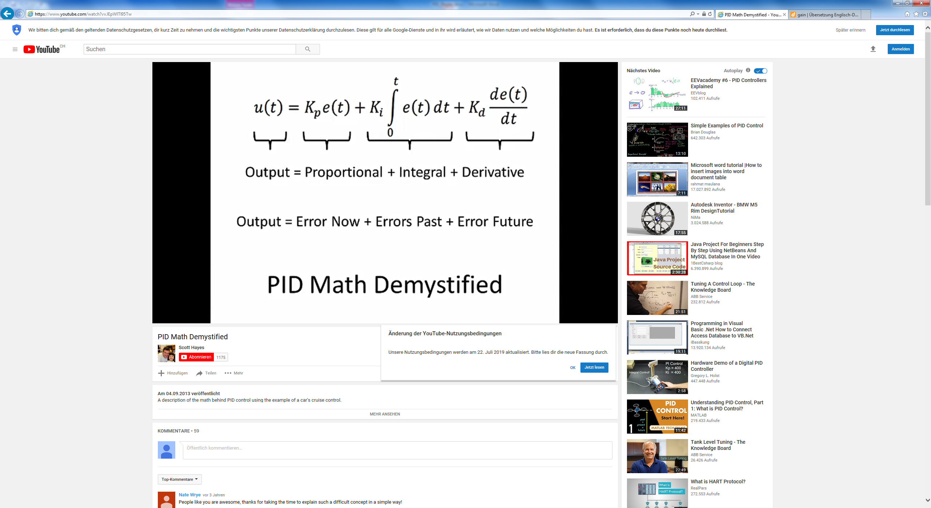

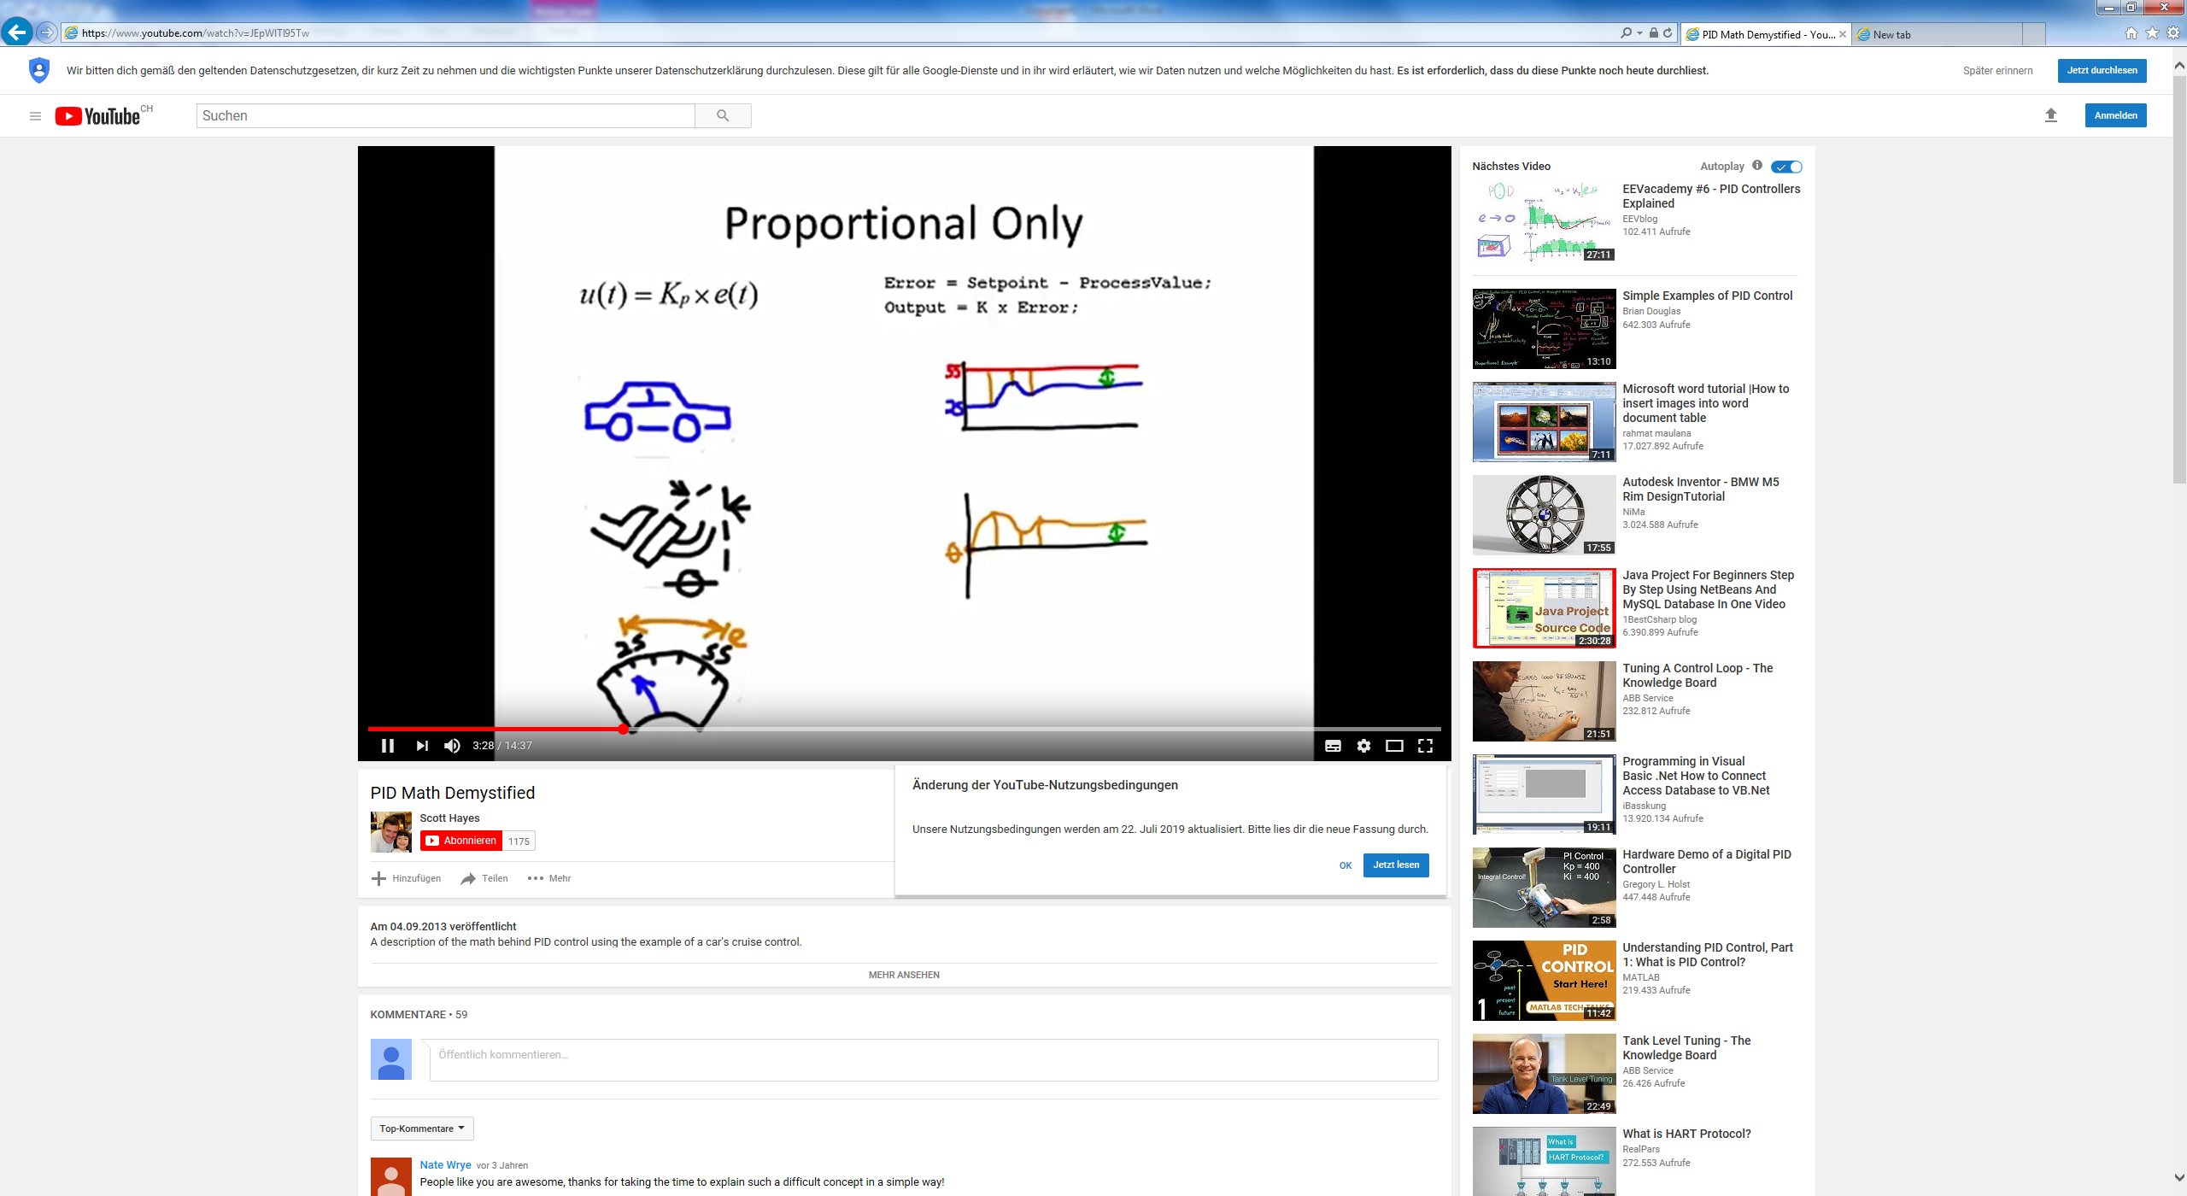

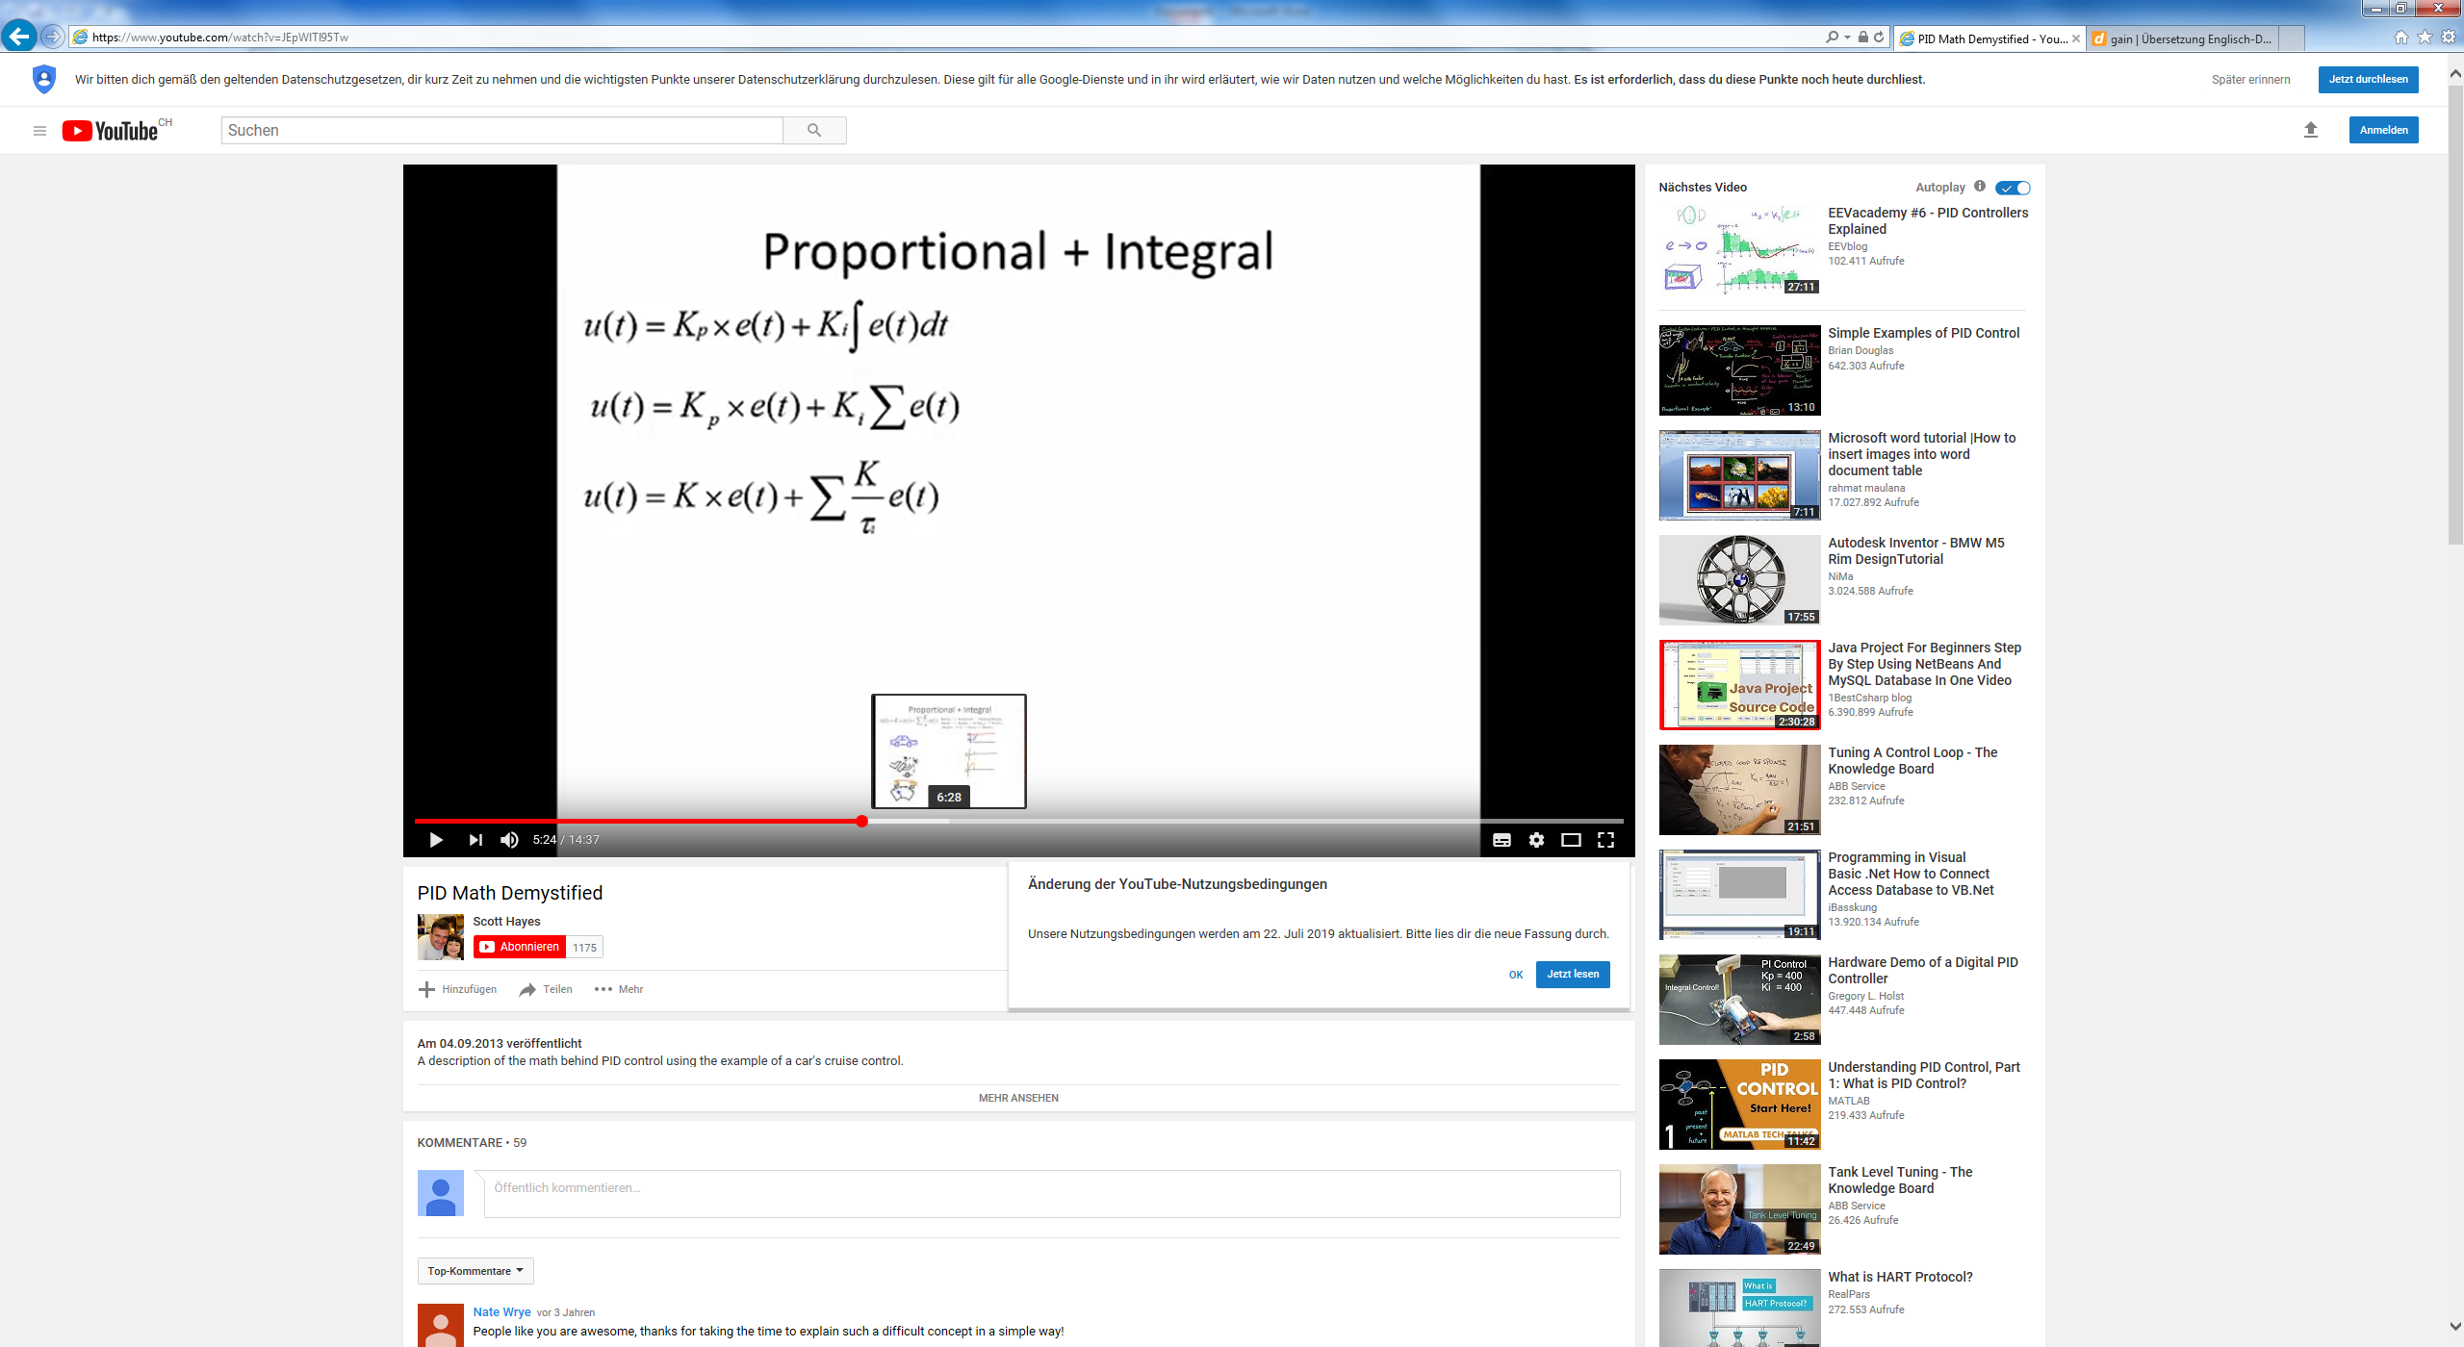

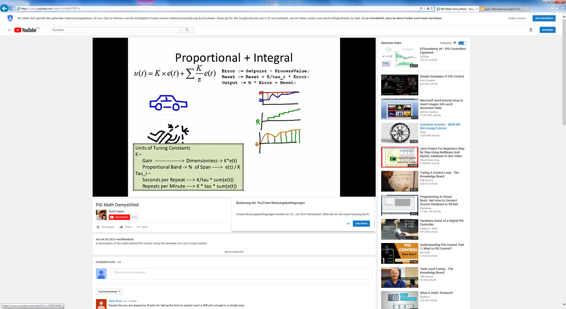

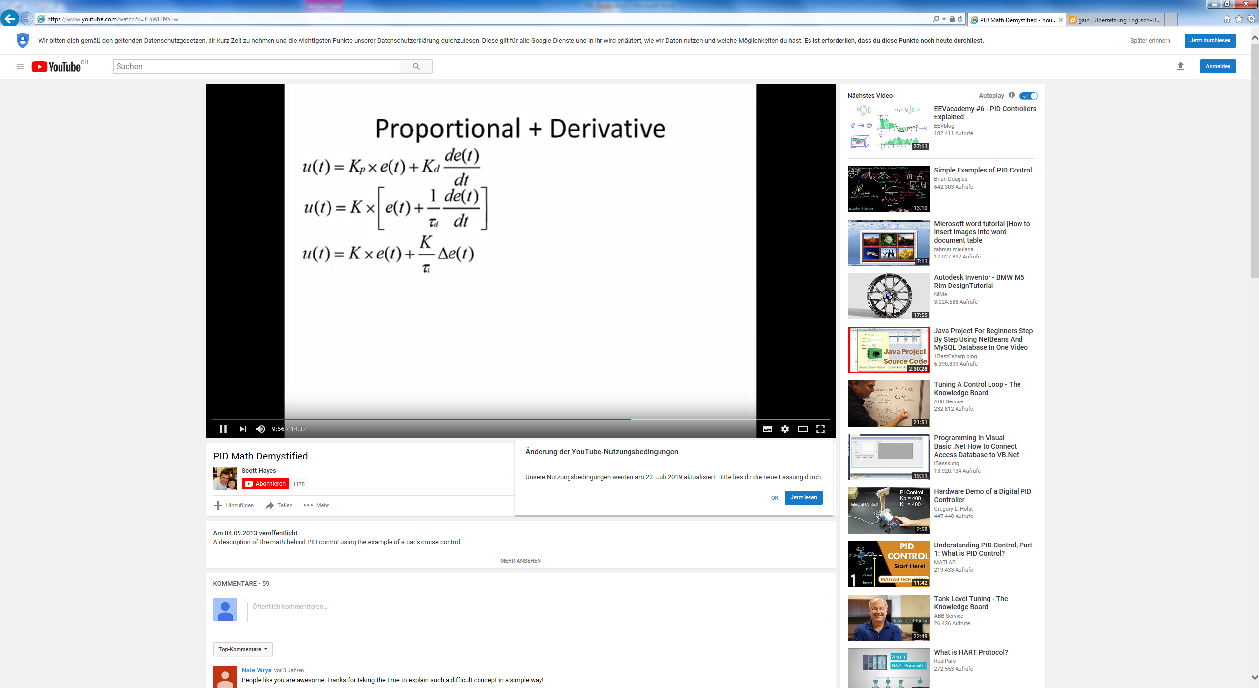

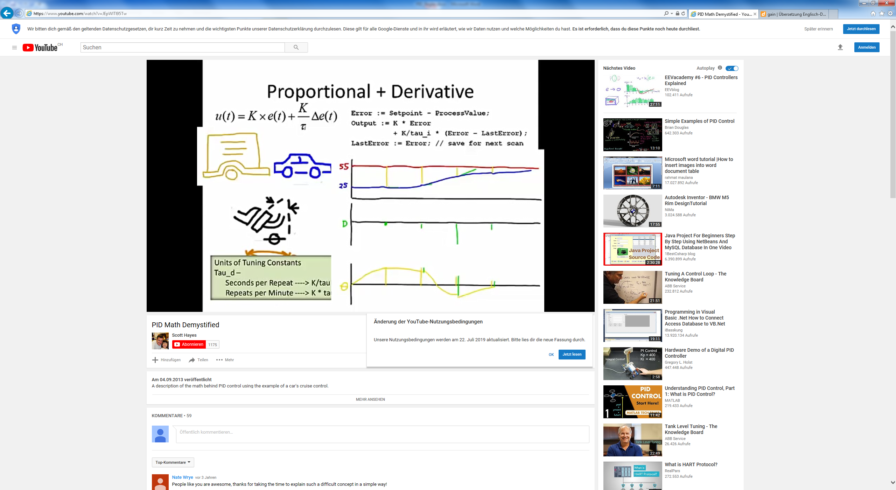

[**https://www.youtube.com/watch?v=XfAt6hNV8XM**](https://www.youtube.com/watch?v=XfAt6hNV8XM)

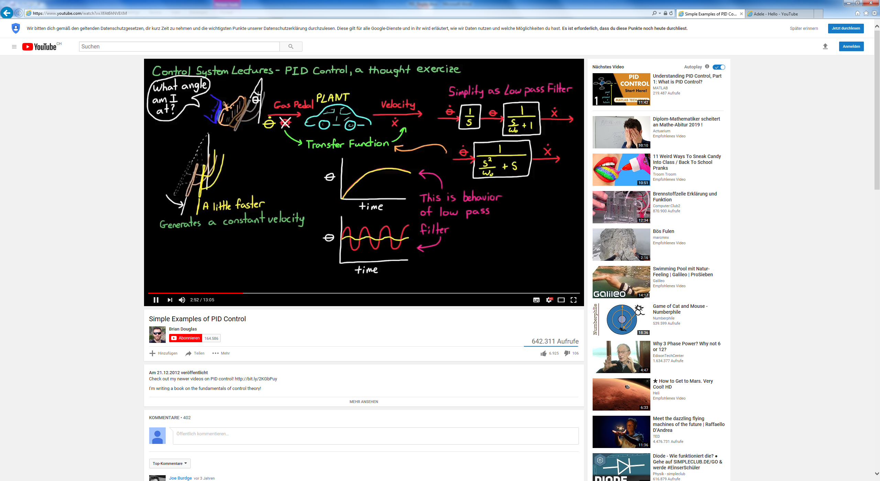

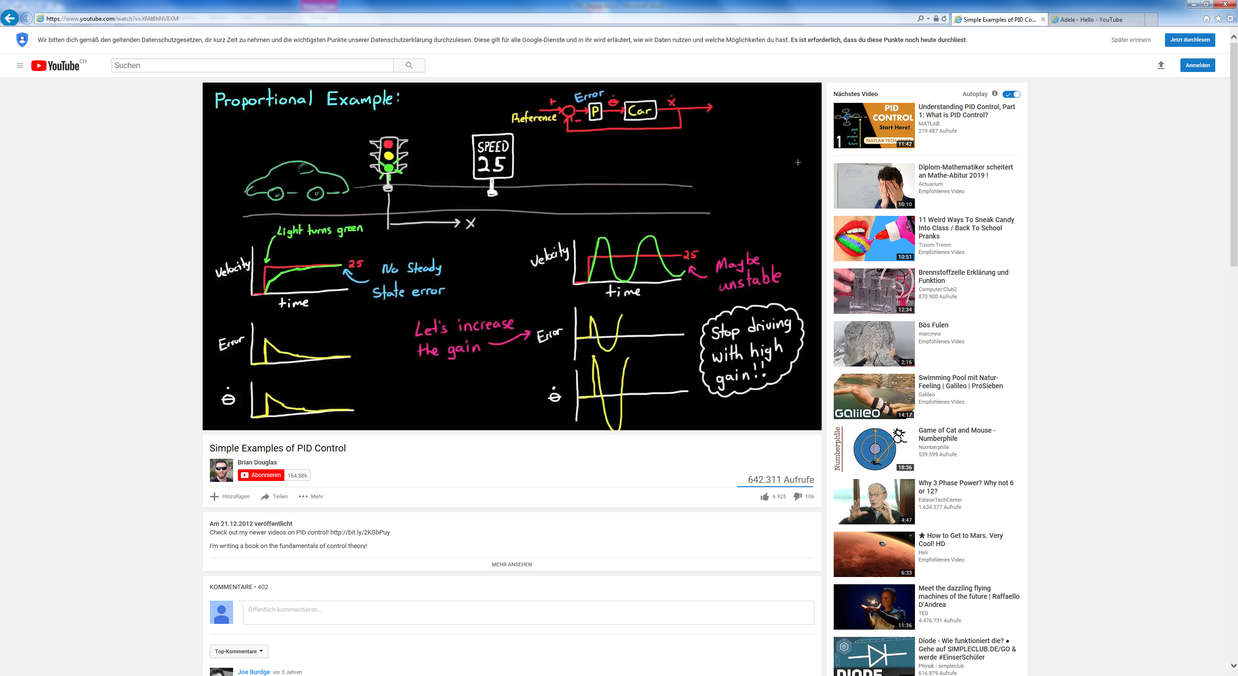

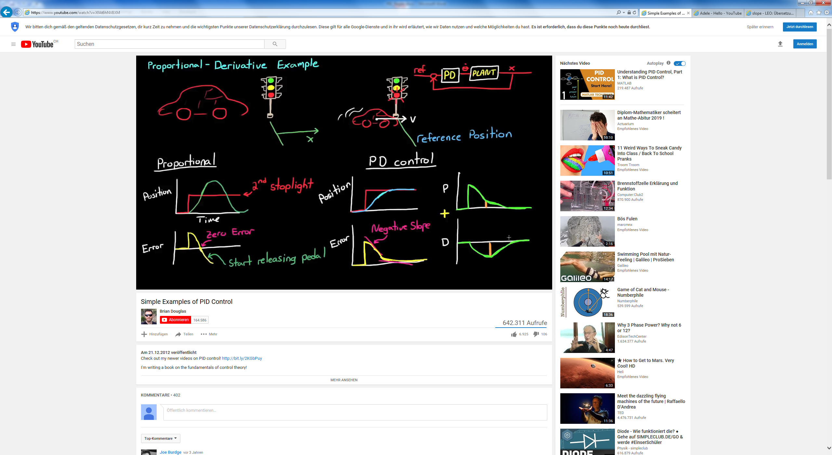

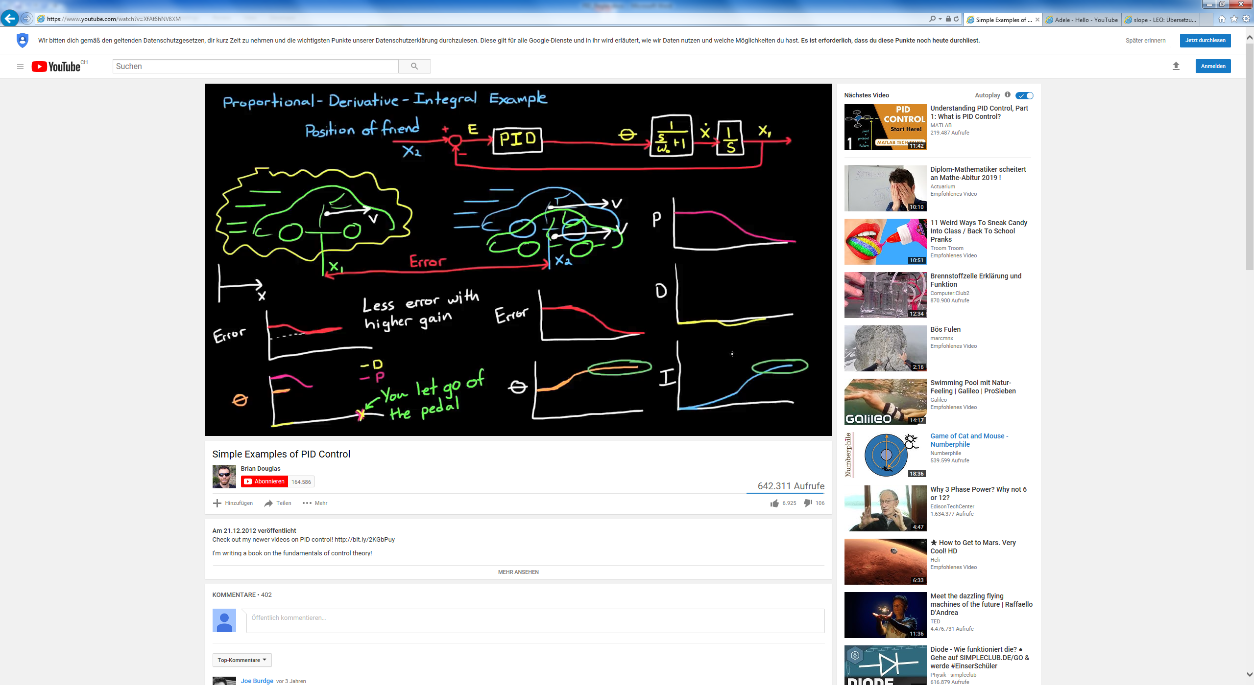

[**https://www.youtube.com/watch?v=wkfEZmsQqiA**](https://www.youtube.com/watch?v=wkfEZmsQqiA)

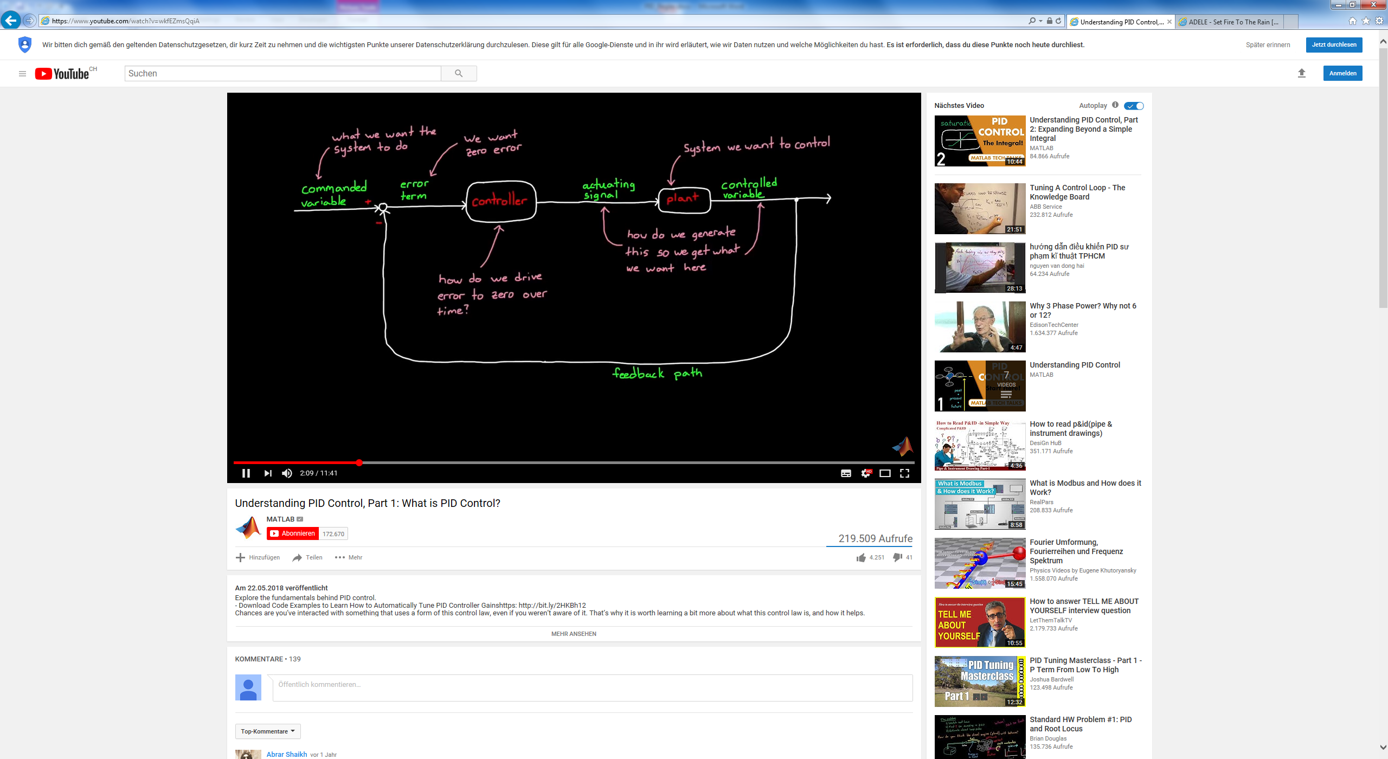

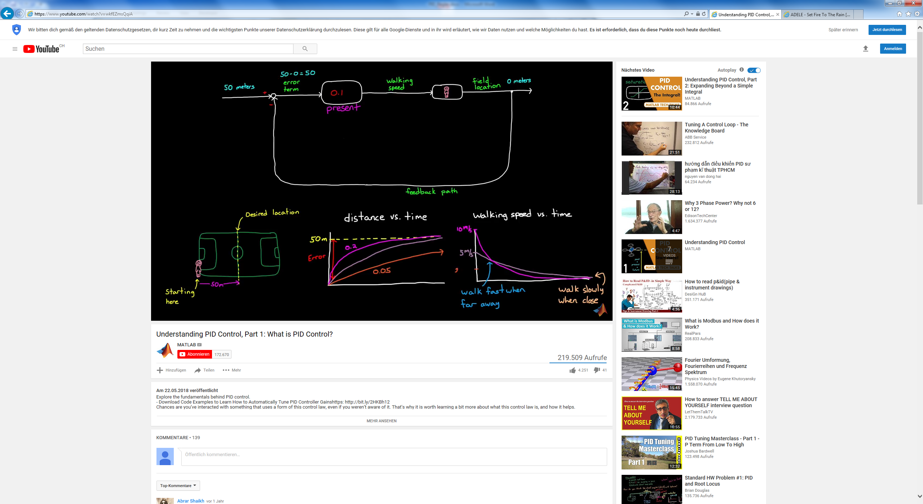

Fehler 0 🡺 Actuating signal 0 P-Regler ist perfekt

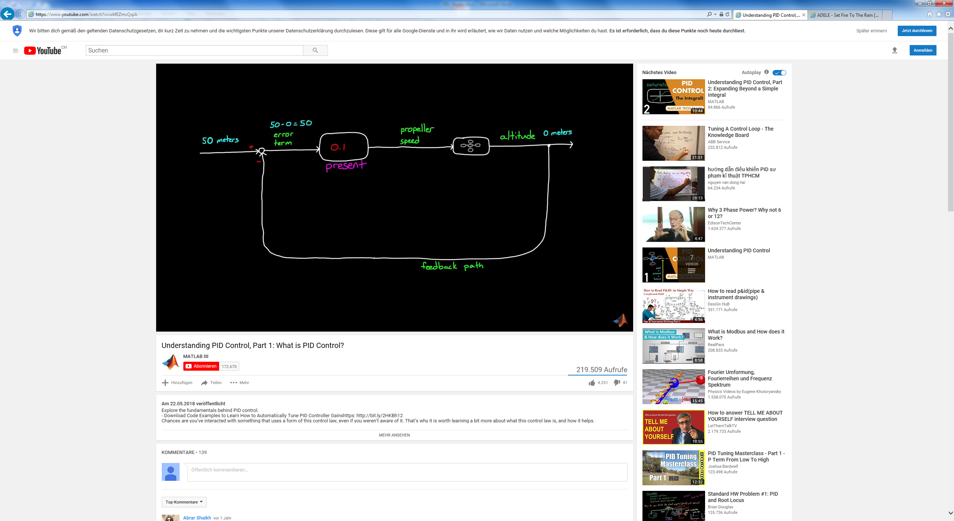

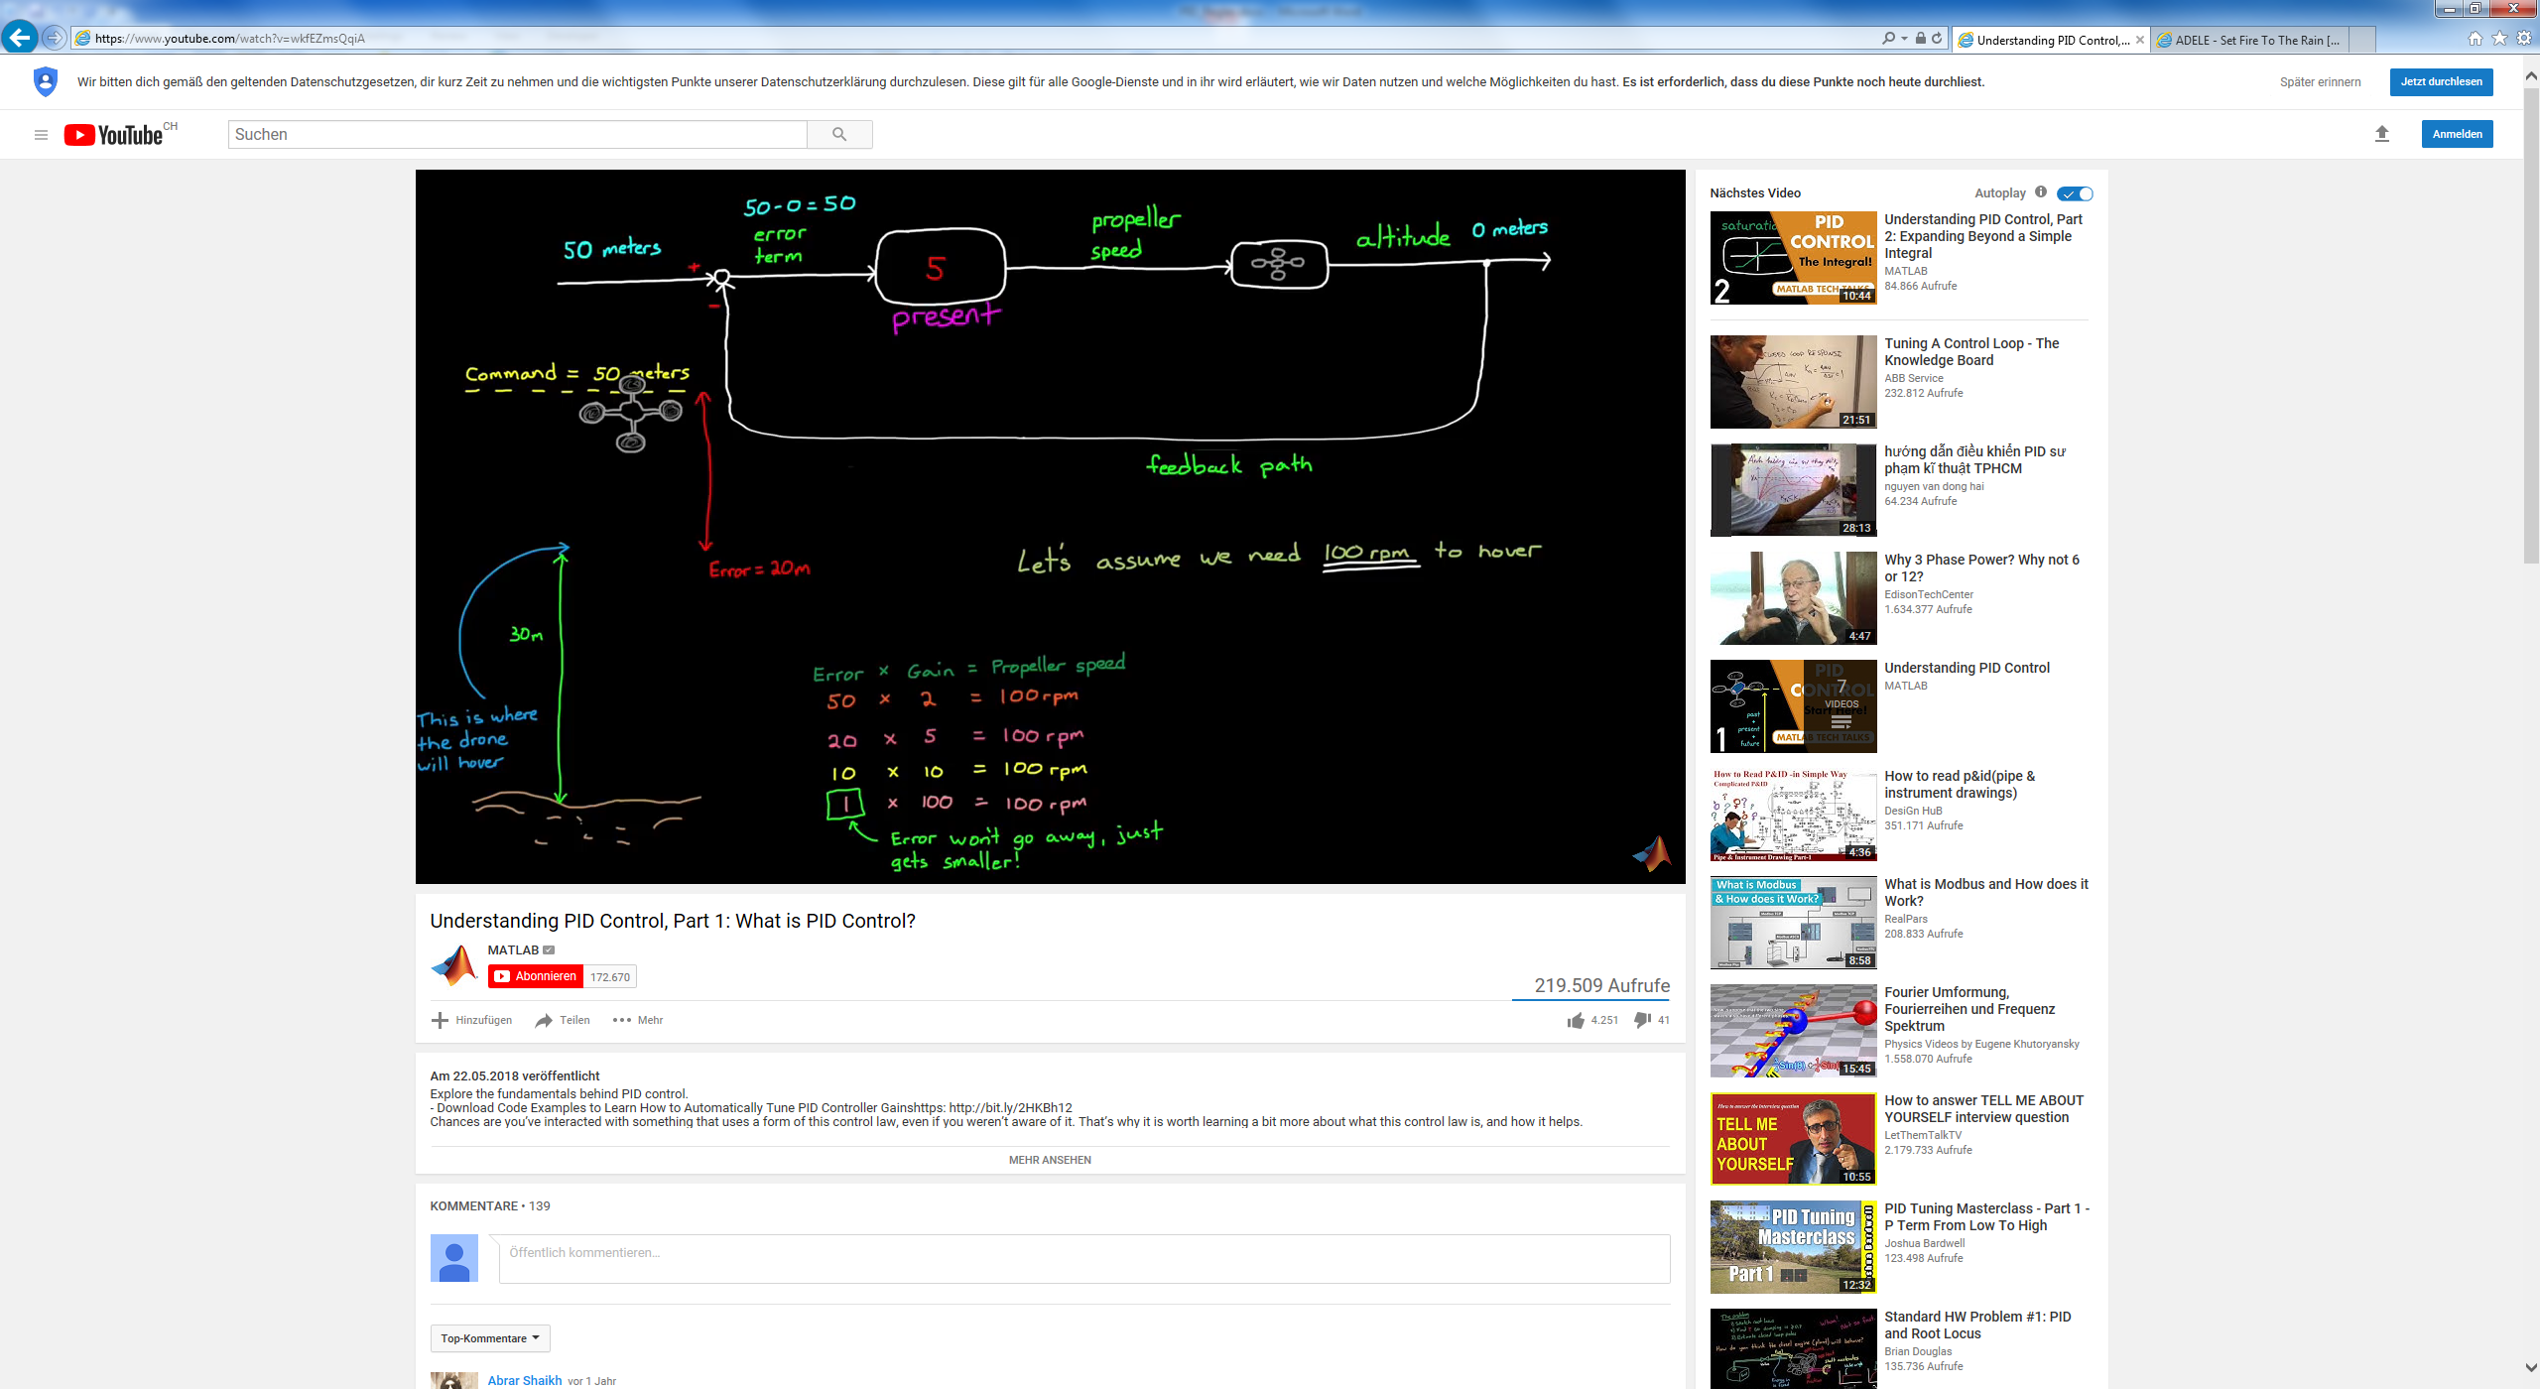

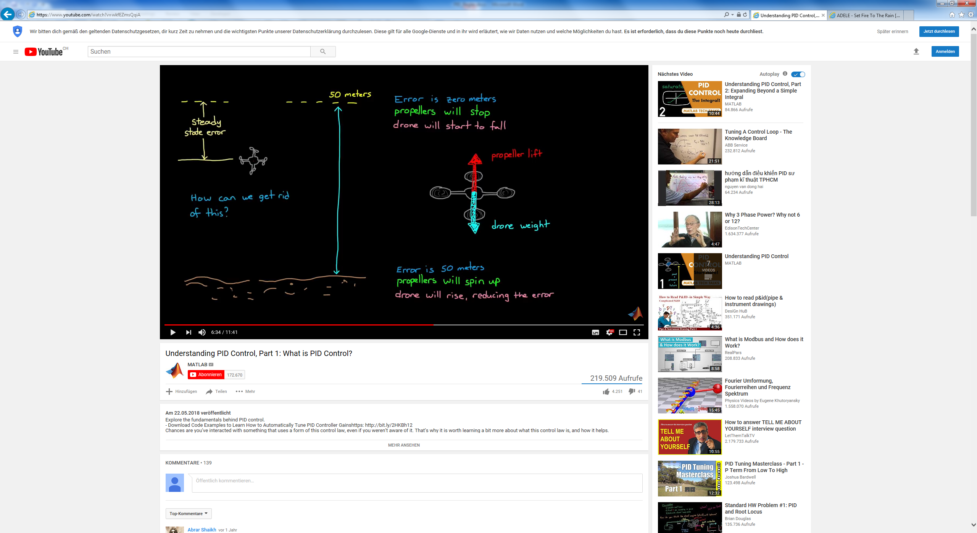

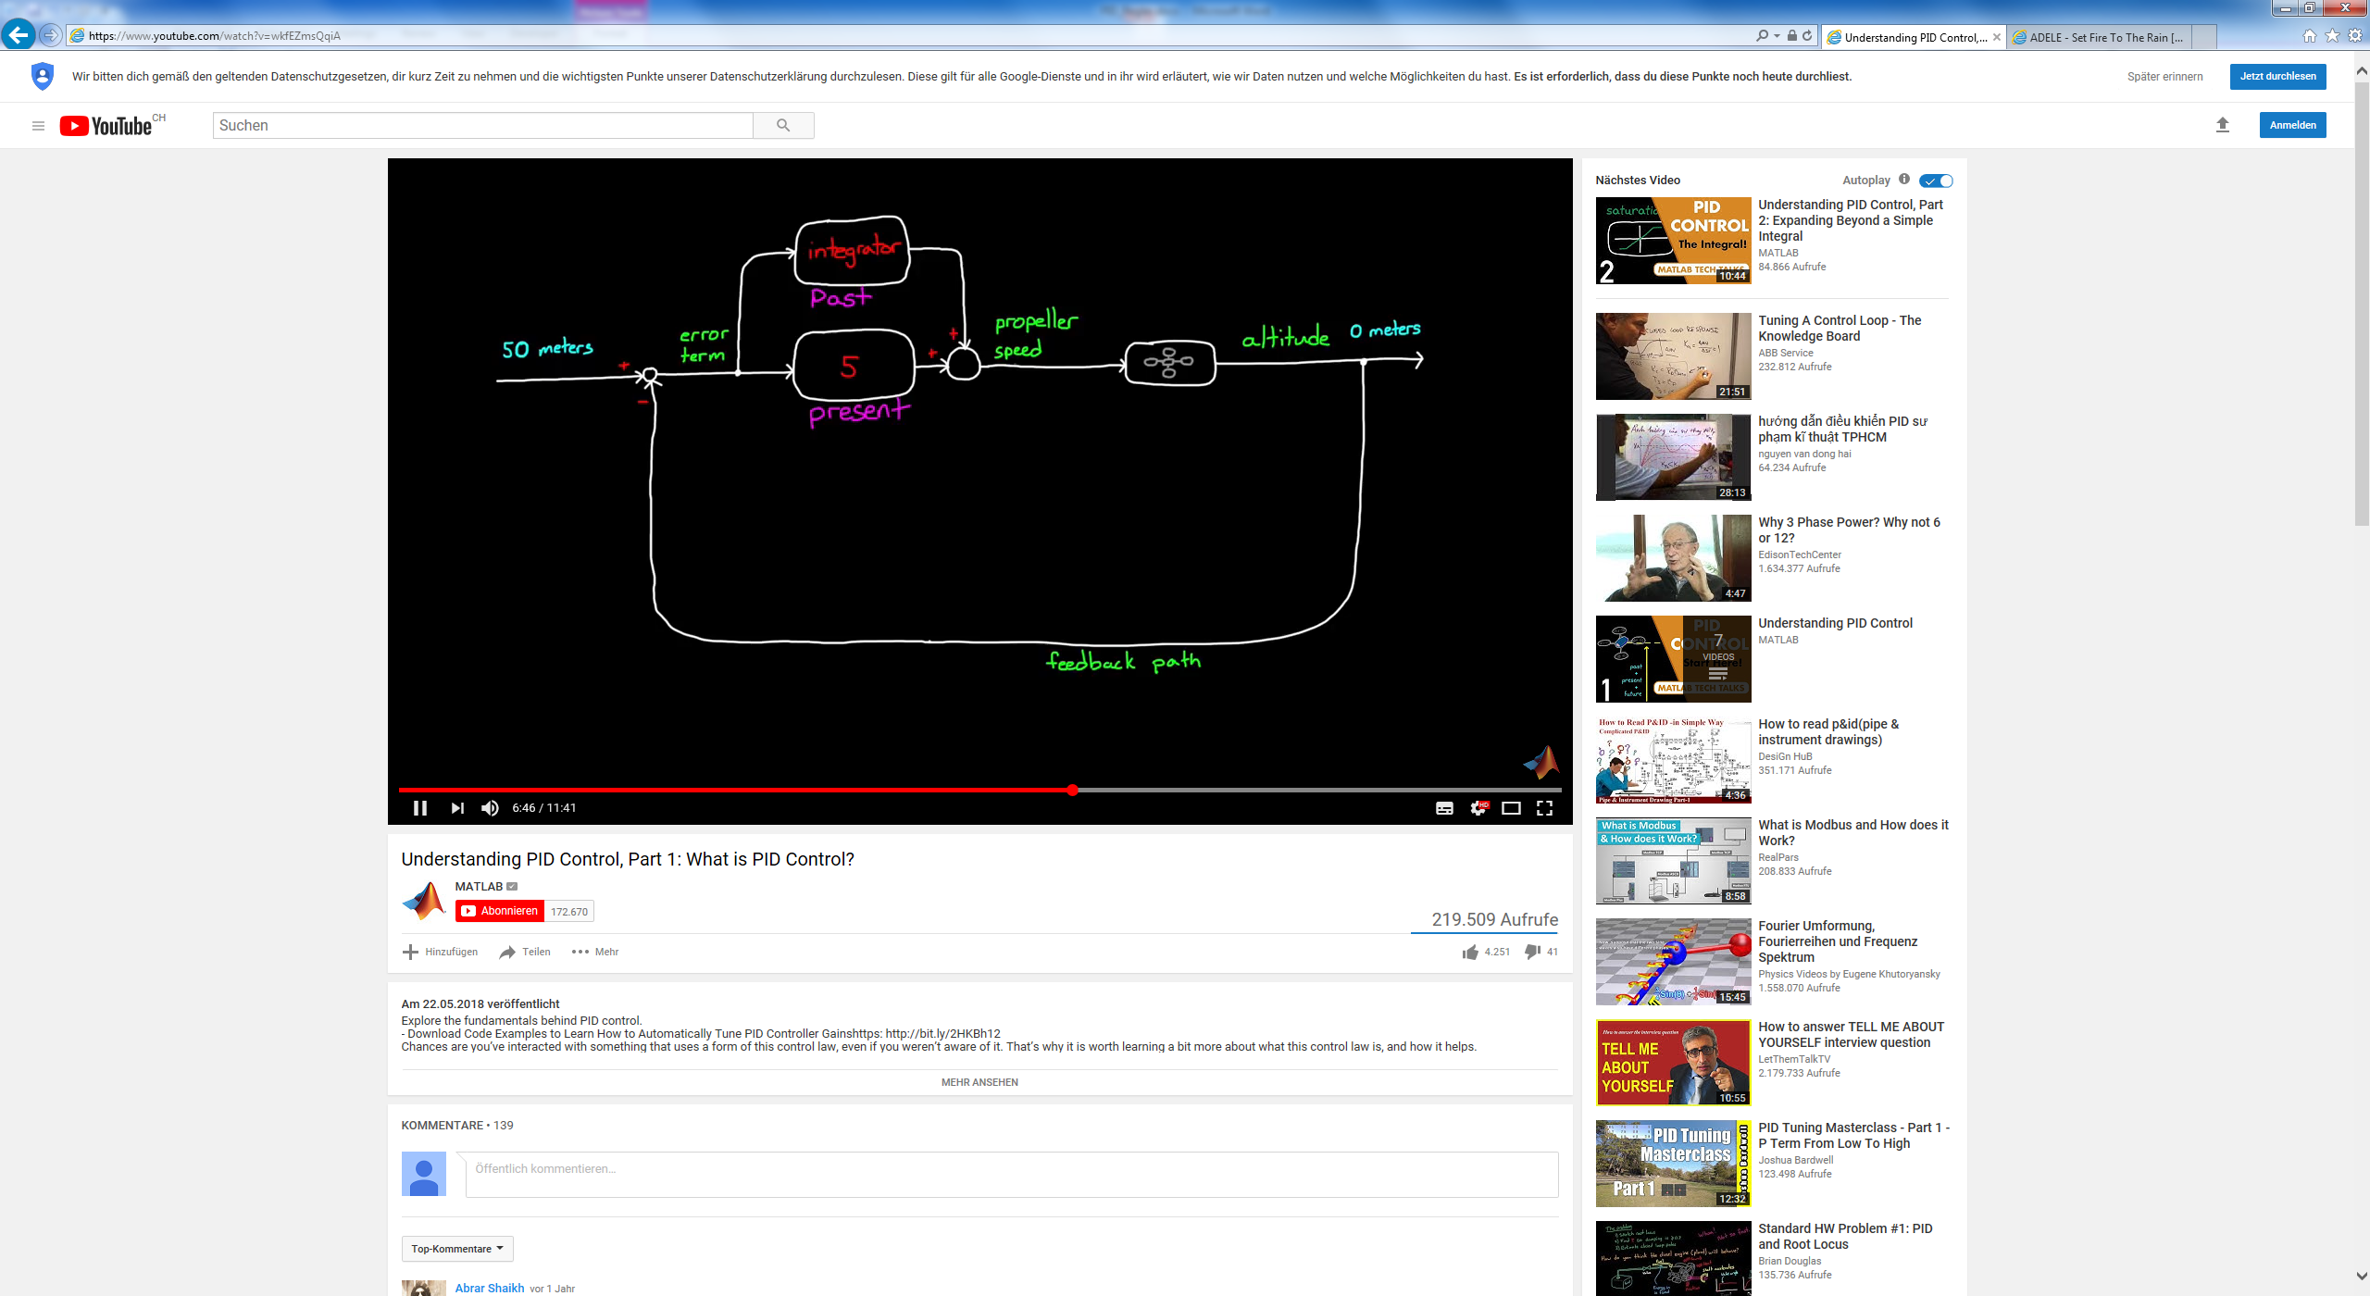

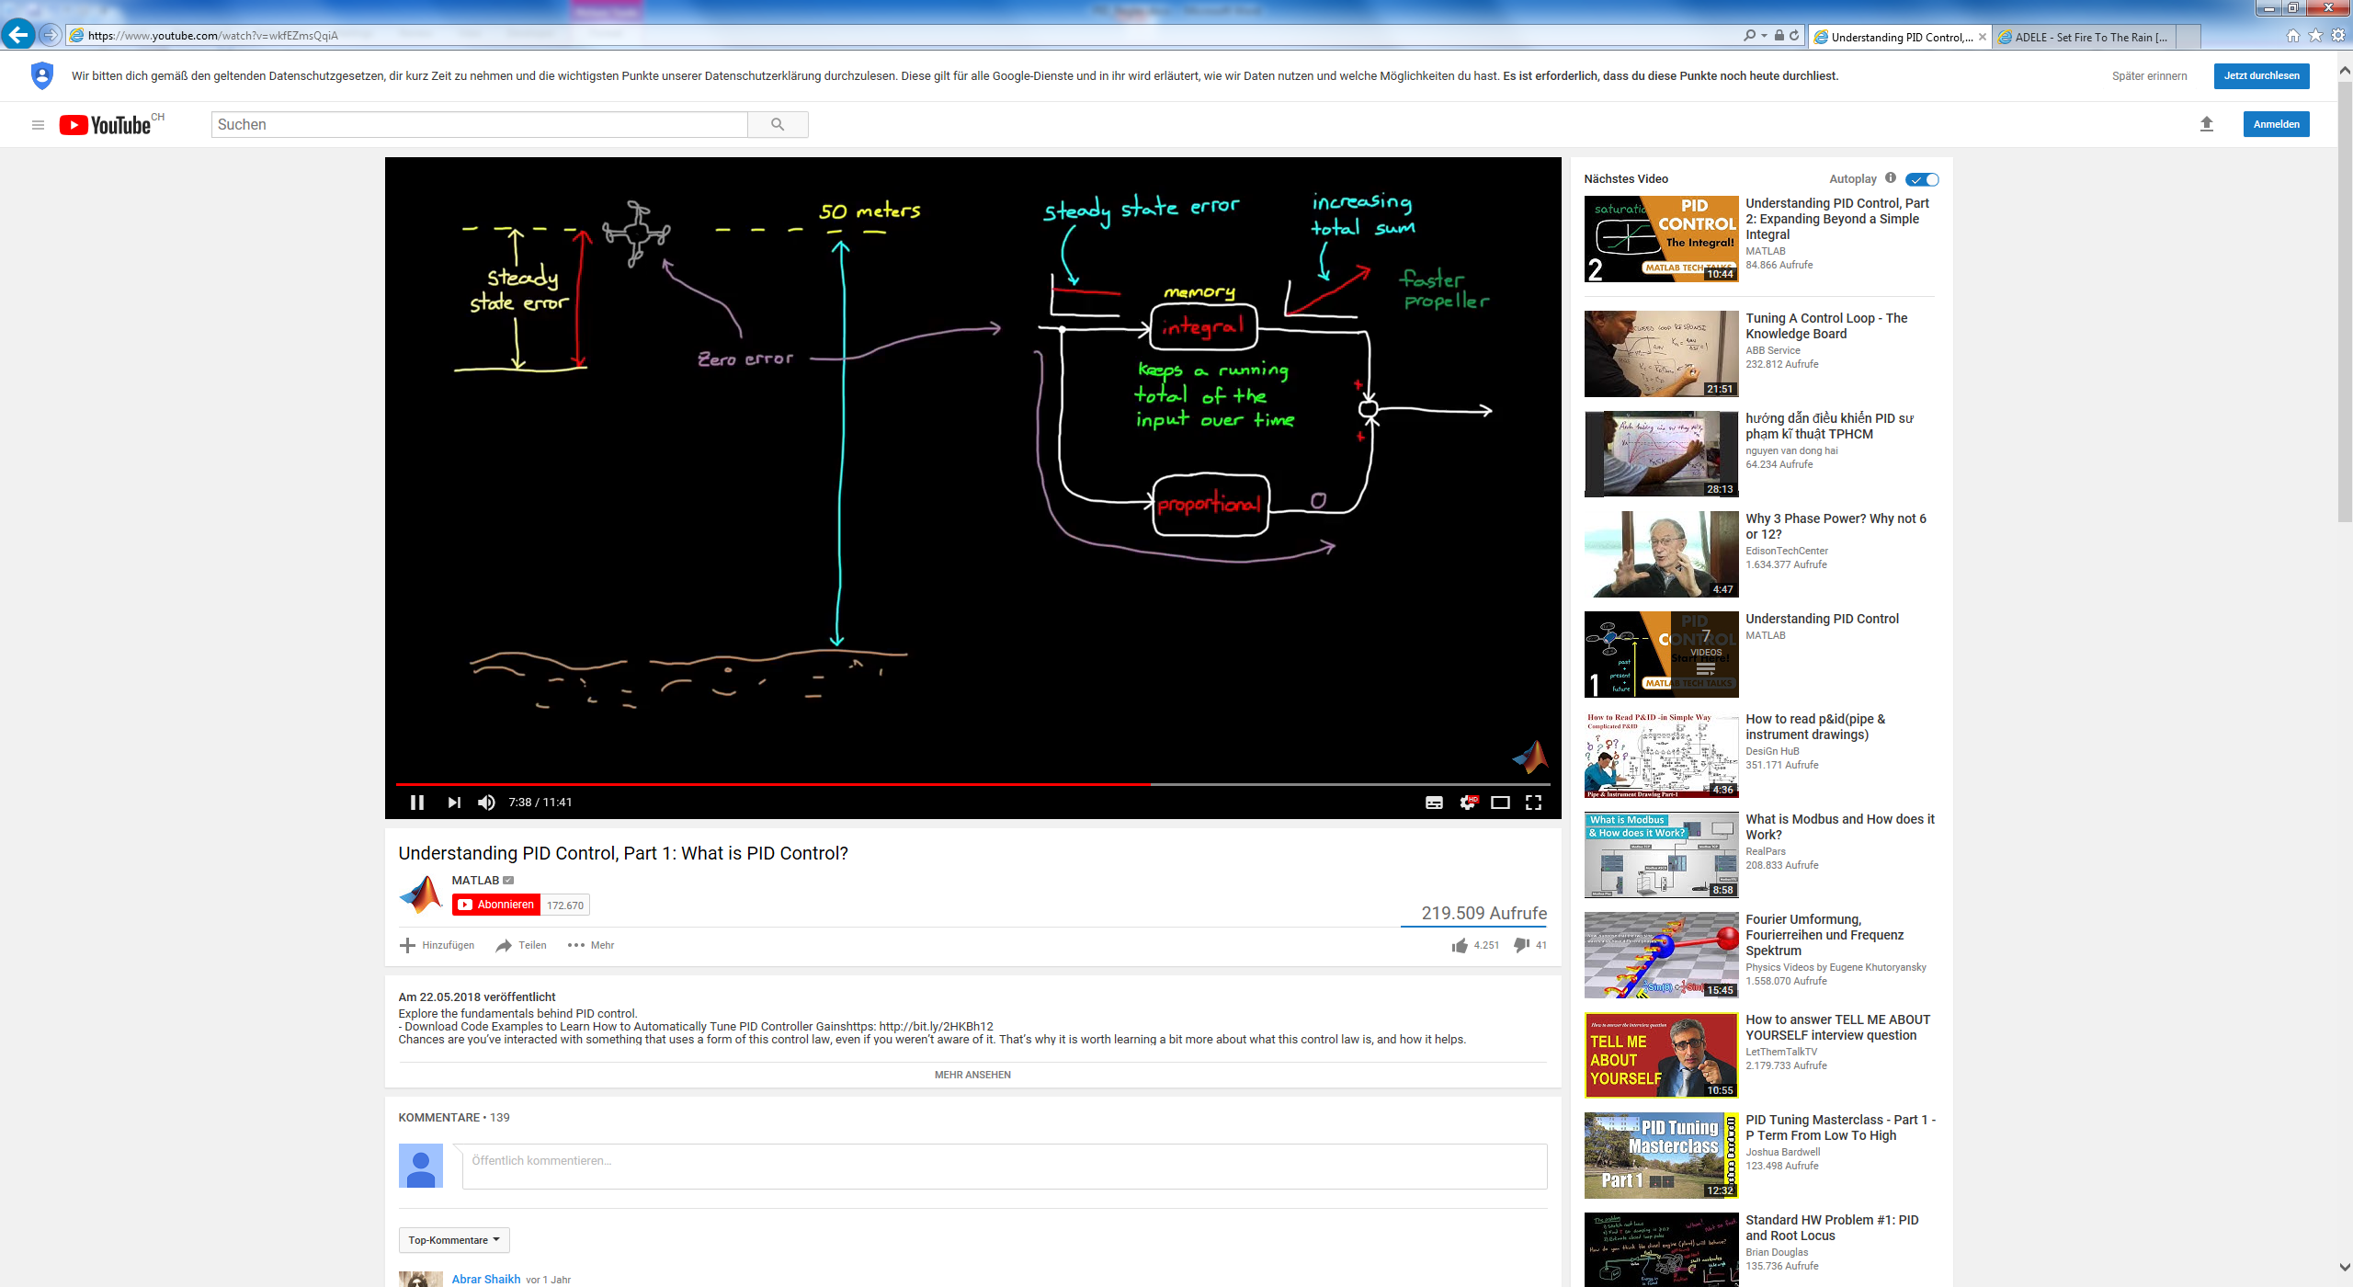

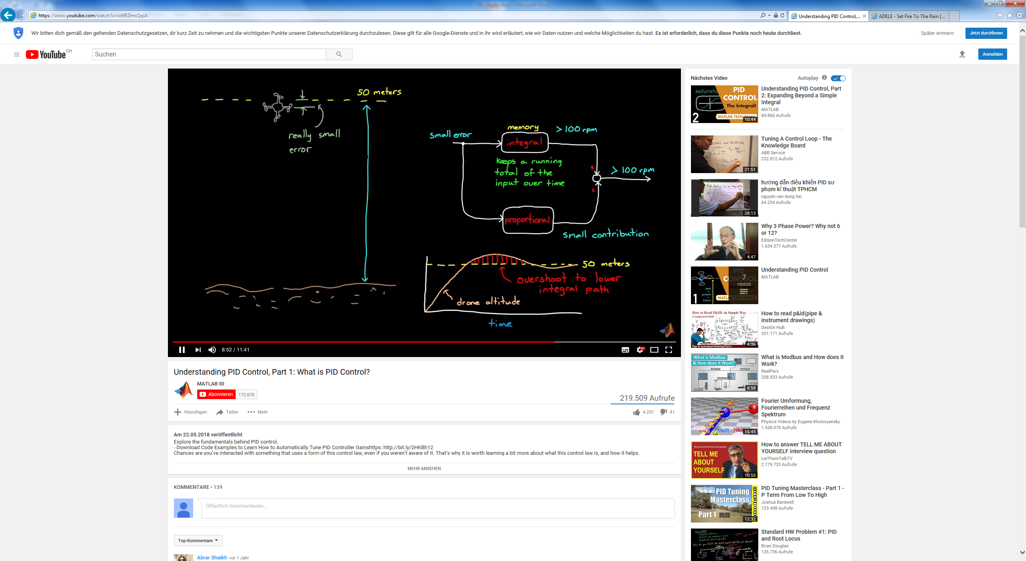

**PT100 / PT1000 Sensor**

[**https://www.youtube.com/watch?v=yEsNTc6P1KU**](https://www.youtube.com/watch?v=yEsNTc6P1KU)

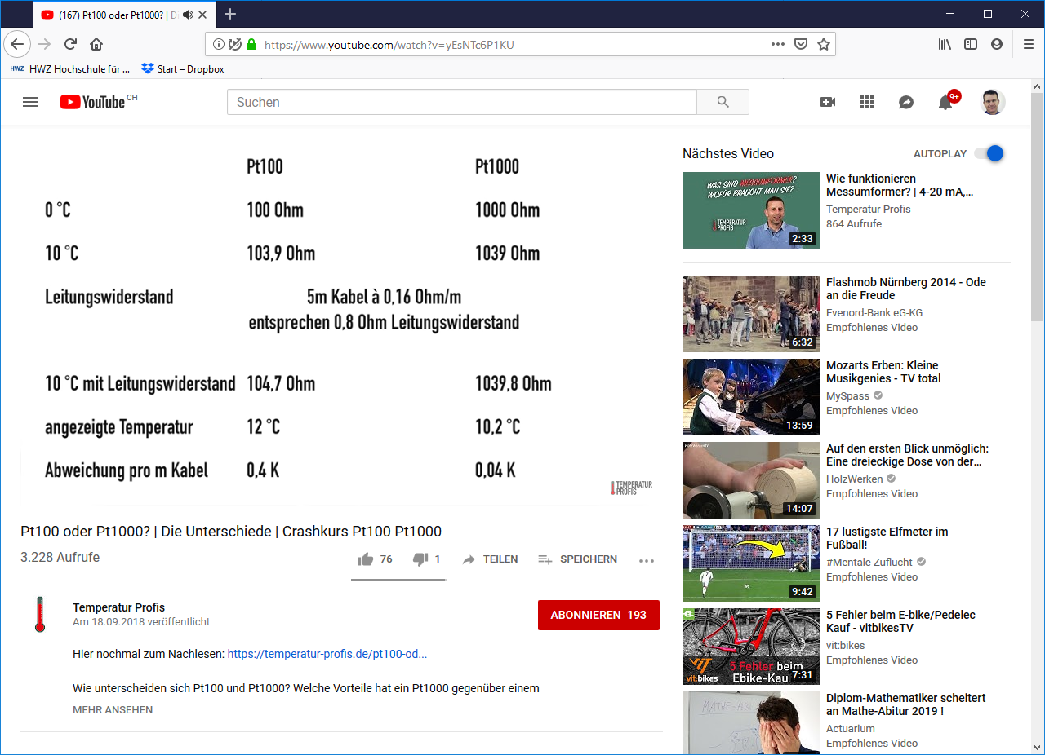

Messfehler: <https://www.youtube.com/watch?v=c5g_rcmS820>

Leiterwiderstand eliminieren (3- resp. 4-Leiter Messung):

<https://www.youtube.com/watch?v=rsJENprkLL0>

